- Simulate the Central Limit Theorem in Python by taking 1000 random samples (size 30) from a skewed dataset (e.g., number of likes on Instagram posts), calculating the mean of each sample, and plotting the histogram of these sample means using matplotlib.
ANSWERS:
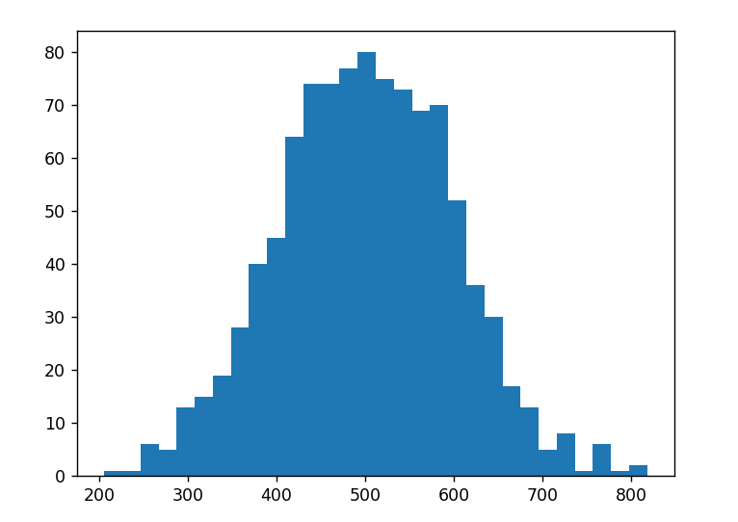
- Explain in your own words why the sampling distribution of the mean becomes approximately normal, even if the original data is not, using an example from any app you use daily (such as Zomato order amounts or Spotify song durations).
ANSWERS: The sampling distribution of the mean becomes approximately normal because when we repeatedly take sufficiently large random samples, high and low values tend to balance out, causing the sample means to form a bell-shaped distribution even when the original data is not normally distributed.
- Pick a real-world scenario from a popular app (Flipkart, Swiggy, or IRCTC) where the Central Limit Theorem could help in analytics or business decision-making. Write a short paragraph describing how CLT would be useful in that context.
ANSWERS:
Flipkart can use the Central Limit Theorem to analyze average delivery times. Individual delivery times may vary widely and may not follow a normal distribution. Flipkart can repeatedly take random samples of 30 orders and calculate the average delivery time for each sample. According to CLT, these sample averages will form an approximately normal distribution. This allows analysts to estimate the overall average delivery time, create confidence intervals, and test whether changes in the delivery system have significantly improved delivery performance.

- Modify the CLT simulation code to use a much smaller sample size (n=5) and compare the histogram of sample means to the one with n=30. Briefly describe what changes you observe in the shape of the distribution.
Hint: Run both simulations and compare the spread and normality of the histograms.
ANSWERS:
When the sample size is 5, the sampling distribution of the mean is more spread out and may be less normally shaped. When the sample size is increased to 30, the distribution becomes more concentrated and approximately bell-shaped. This shows that larger sample sizes make the Central Limit Theorem more effective.
5.) Use ChatGPT to generate Python code that demonstrates the Central Limit Theorem using random samples from a non-normal distribution (e.g., exponential). Run the code, paste the output plot, and briefly describe what you observe.
ANSWERS:
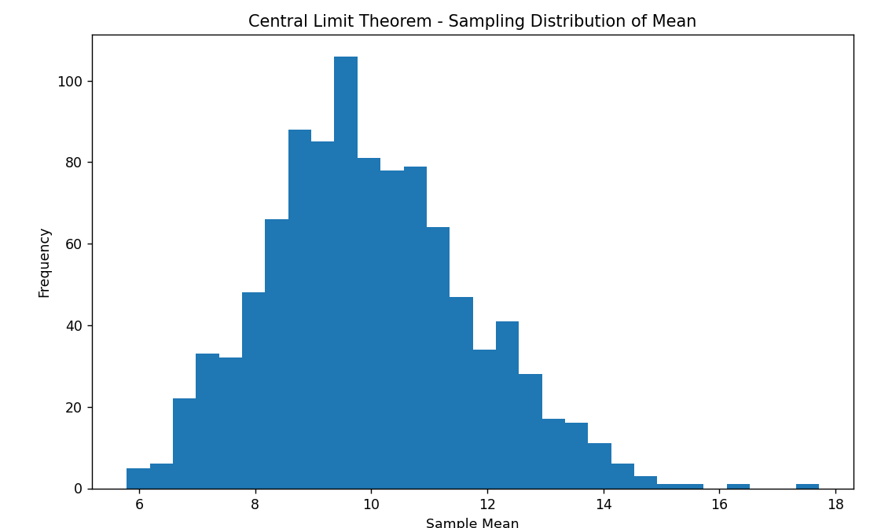
The original exponential distribution is non-normal and right-skewed. However, after taking 1,000 random samples of size 30 and calculating their means, the distribution of the sample means becomes approximately bell-shaped and normal. This demonstrates the Central Limit Theorem.

